**Ideation Phase**

**Define the Problem Statements**

|  |  |
| --- | --- |
| Date | 30/10/2025 |
| Team ID | NM2025TMID01257 |
| Project Name | Calculating Family Expenses using ServiceNow |
| Maximum Marks | 4 Marks |

**Brainstorm & Idea Prioritization Template:**

The Brainstorm Grid helps generate and organize ideas that solve user problems creatively.  
For this project Calculating Family Expenses Using ServiceNow the brainstorming focuses on simplifying how families manage their budgets and expenses.  
The goal is to identify practical and innovative features that can help users record, categorize, and analyze their financial data effectively.

**Step-1: Team Gathering, Collaboration and Select the Problem Statement**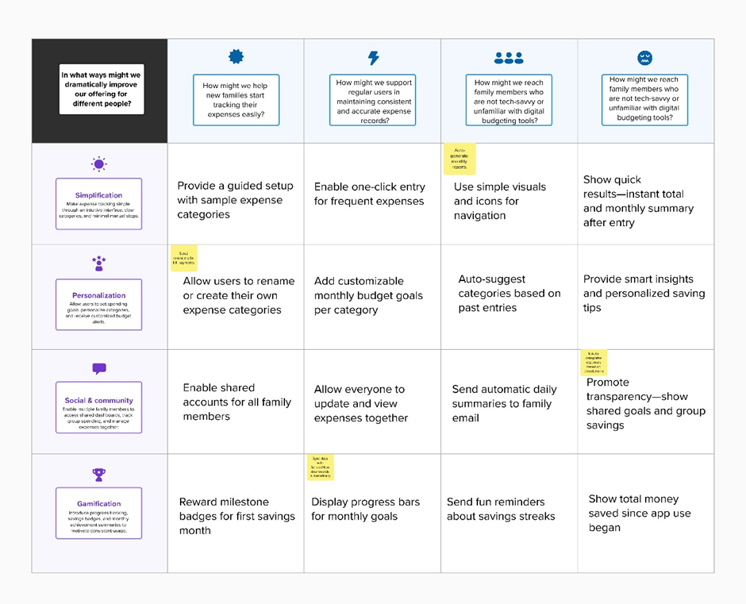

**Step-2: Brainstorm, Idea Listing and Grouping**

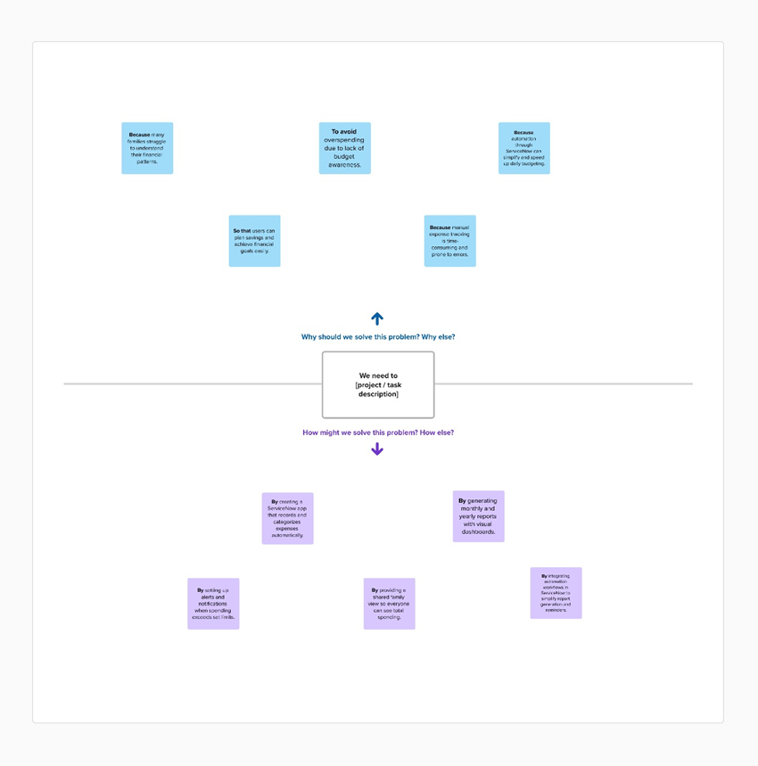

**Step-3: Idea Prioritization**

